**Ganpat University**

**Faculty of Engineering & Technology**

**Computer Science & Engineering**

***Name:- Dwij Vatsal Desai***

***Sem:- 2***

***Sub: - BOSS***

***Enrollment No.:- 23162121027***

***Prac:- 10***

***Date:- 20/4/2024***

**Practical 10**

1. List the current network scenario of your system..

***Command:-***

nmcli con show

***Image:-***

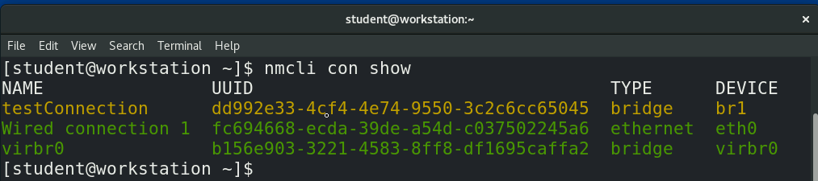

1. Configure your IP Address, Gateway and DNS as follows:

IP Address:192.168.100.XXX/24

Gateway 192.168.100.100

DNS:192.168.100.100

(The name of the connection should be yourname_surname)

***Command:-***

nmcli connection add con-name dwij ifname eth0 type ethernet ip4 192.168.100.249/24 gw4 192.168.249.100

nmcli connection modify dwij ipv4.dns 192.168.100.249

nmcli con show

***Image:-***

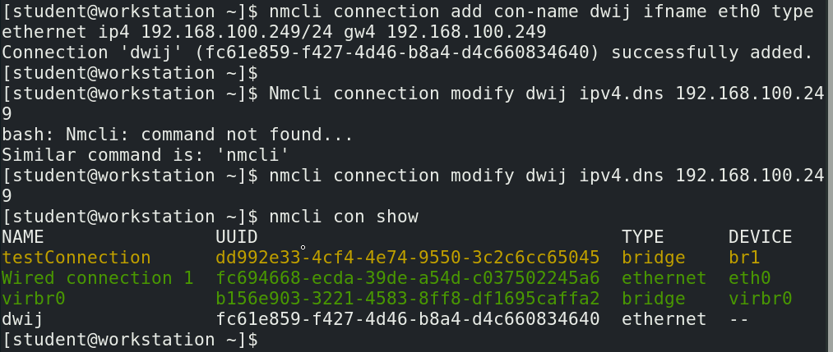

1. Activate the newly added network connection

***Command:-***

nmcli con up dwij

***Image:-***

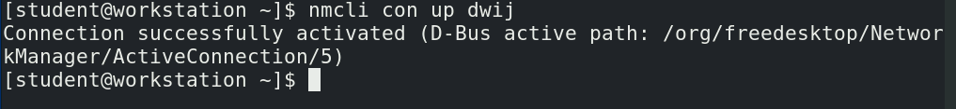

1. Display the details of newly added connection

***Command:-***

nmcli con show dwij

***Image:-***

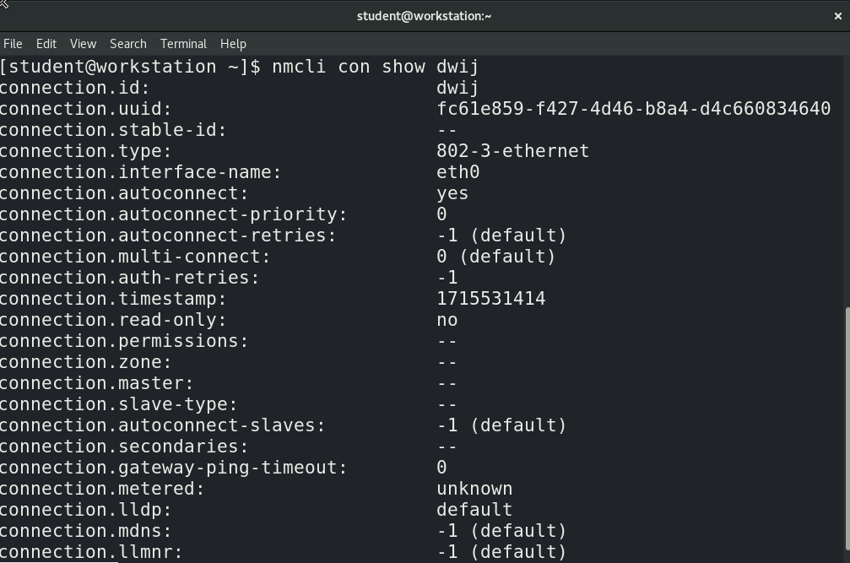

1. Delete the newly added connection and restore the previous network connection scenario.

***Command:-***

nmcli con del dwij

nmcli con show

***Image:-***

